1. **ReactJS-HOL**

**Question:** My Academy team at Cognizant want to create a dashboard containing the details of ongoing and completed cohorts. A react application is created which displays the detail of the cohorts using react component. You are assigned the task of styling these react components.

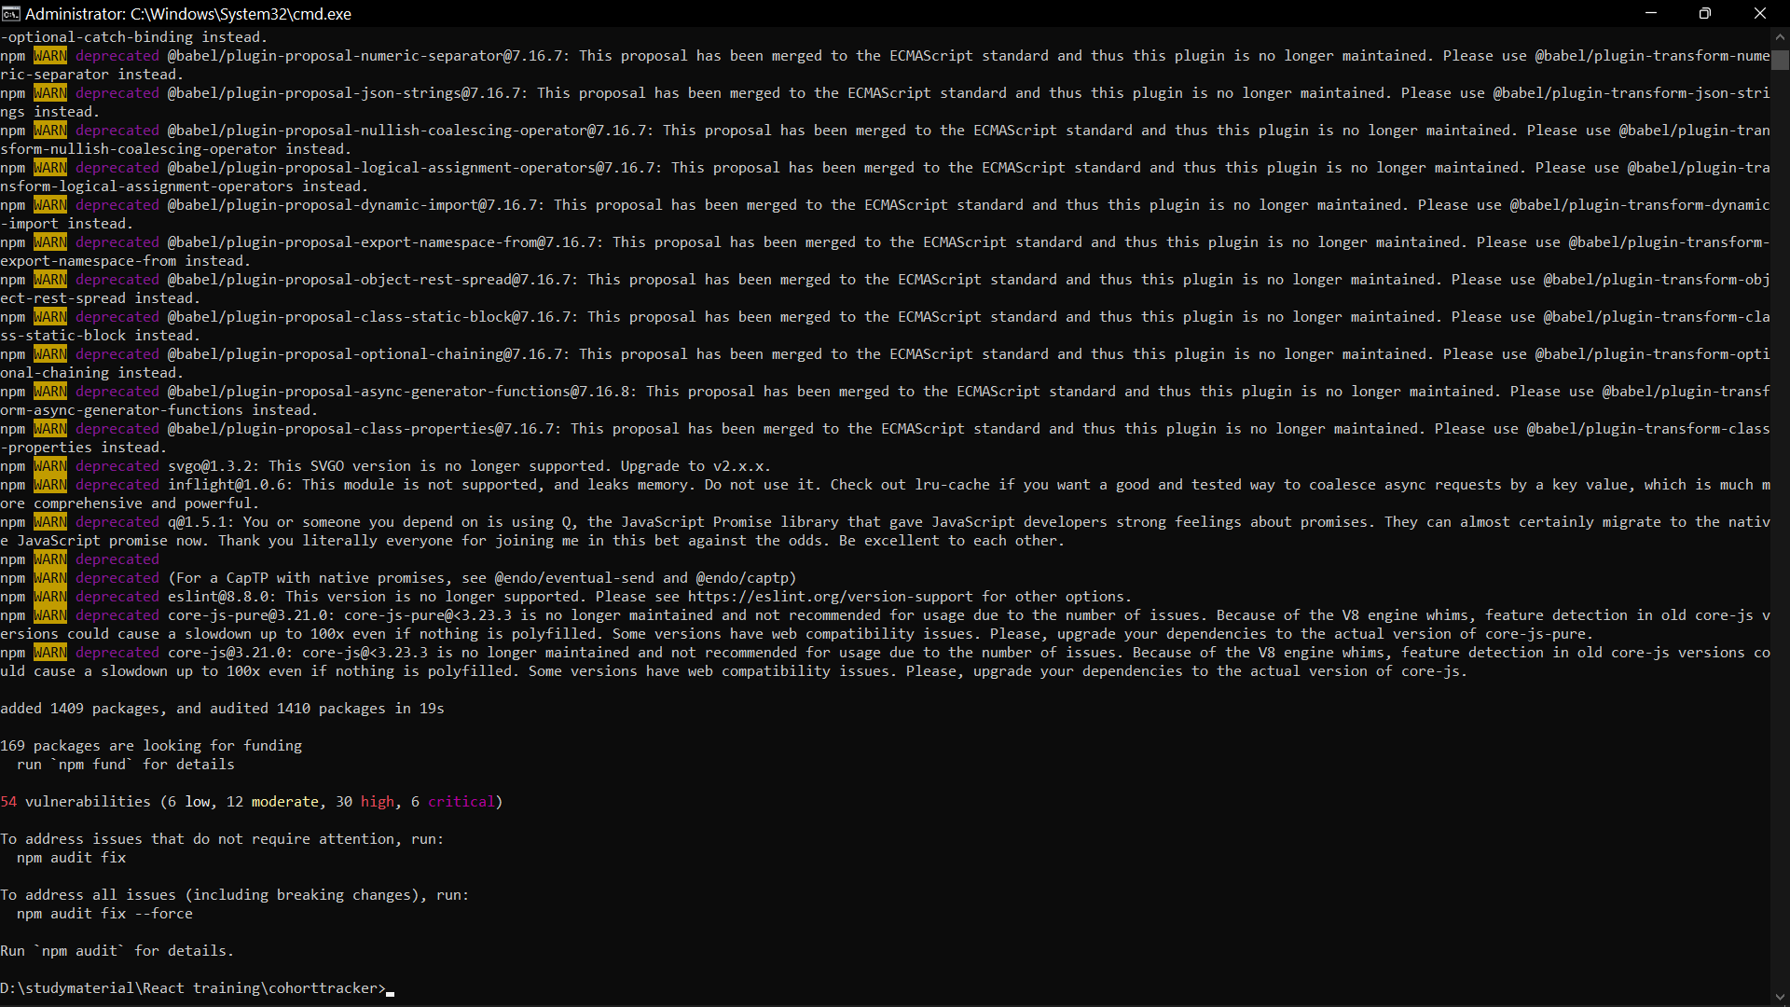

**Code:**

**CohortDetails.module.css :**

.box {

width: 300px;

display: inline-block;

margin: 10px;

padding: 10px 20px;

border: 1px solid black;

border-radius: 10px;

vertical-align: top;

}

dt {

font-weight: 500;

}

.heading {

font-size: 20px;

font-weight: bold;

margin-bottom: 10px;

}

[**CohortDetails.js**](http://cohortdetails.js) **:**

import React from 'react';

import styles from './CohortDetails.module.css';

function CohortDetails({ name, startedOn, status, coach, trainer }) {

const nameStyle = {

color: status.toLowerCase() === 'ongoing' ? 'green' : 'blue',

fontWeight: 'bold',

fontSize: '16px'

};

return (

<div className={styles.box}>

<div style={nameStyle}>{name}</div>

<dl>

<dt>Started On</dt>

<dd>{startedOn}</dd>

<dt>Current Status</dt>

<dd>{status}</dd>

<dt>Coach</dt>

<dd>{coach}</dd>

<dt>Trainer</dt>

<dd>{trainer}</dd>

</dl>

</div>

);

}

export default CohortDetails;

[**App.js**](http://app.js) **:**

import React from 'react';

import CohortDetails from './CohortDetails';

function App() {

return (

<div style={{ border: '1px solid black', padding: '20px' }}>

<h2 style={{ fontWeight: 'bold' }}>Cohorts Details</h2>

<CohortDetails

name="INTADMDF10 - .NET FSD"

startedOn="22-Feb-2022"

status="Scheduled"

coach="Aathma"

trainer="Jojo Jose"

/>

<CohortDetails

name="ADM21JF014 - Java FSD"

startedOn="10-Sep-2021"

status="Ongoing"

coach="Apoorv"

trainer="Elisa Smith"

/>

<CohortDetails

name="CDBJF21025 - Java FSD"

startedOn="24-Dec-2021"

status="Ongoing"

coach="Aathma"

trainer="John Doe"

/>

</div>

);

}

Export default App;

**Output :**

